Ideation Phase
Define the Problem Statements

Date | 30/09/2026
Team ID | 6ab3d79c6603573ccfb36fe0
Project Name | AI FitTrack
Maximum Marks | 2 Marks

Customer Problem Statement
Fitness users often find it difficult to choose the right workout based on their fitness goals, activity level, and personal preferences. General workout plans may not be suitable for every user because each person has different fitness needs.
Users need a simple system that can understand their requirements and provide suitable fitness recommendations. They also need guidance to follow a proper workout routine without spending too much time planning it.
FitSense addresses this problem by using Artificial Intelligence to provide personalized fitness recommendations. The system analyzes user information and suggests suitable workouts based on their individual needs and goals.

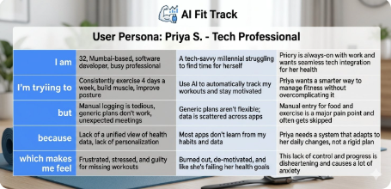

Example:

Problem Statement (PS) | I am (Customer) | I’m trying to | But | Because | Which makes me feel
PS-1  (Busy Professional) | A busy working professional who wants to stay healthy but struggles to maintain a consistent exercise routine | Automatically track my daily workouts and stay consistent with my long-term fitness goals. | Manual logging takes too much time, and generic workout plans do not adapt to my daily schedule changes | Current apps lack real-time personalization and fail to adjust when my energy or free time fluctuates. | Demotivated, overwhelmed, and guilty for frequently falling off track with my health goals.
PS-2  (Fitness Beginner) | A complete fitness beginner looking for guidance but gets easily overwhelmed by complex gym environments. | Start a simple, structured exercise routine at home and track basic progress effortlessly. | Most tracking platforms are too complicated to navigate and use technical gym jargon. | They are designed for fitness experts rather than average individuals trying to build a new lifestyle habit. | Intimidated, lost, and unmotivated to continue my fitness journey.

